Dsa notes to the point clearing the concepts,
postfix and prefix is not explain in it learn from the Ehsan khalil notes the dsa master only moving with his belly mottu

1. What is Data Structure? (Definition)
A Data Structure is a way to store, organize, and manage data so that it can be used efficiently.
In simple words:
It tells how data is arranged in memory so operations like searching, inserting, deleting, and updating become fast.

Examples:
Array
Linked List
Stack
Queue
Tree
Graph
Hash Table

2. What is an Algorithm?
An algorithm is a step-by-step procedure to solve a problem.
It is the logic of how a task will be done.
3. What is Data Structures and Algorithms (DSA)?
DSA = Efficient data + efficient logic
It is the combined study of:
Data Structures → How data is stored
Algorithms → How problems are solved
Together, they help in writing fast, optimized, and scalable programs.
4. Program WITH DSA vs WITHOUT DSA
Without DSA (Bad program)
Uses normal variables and simple arrays
Works only for small inputs
Becomes slow when data becomes large
Memory usage becomes high
Searching, sorting, operations become very slow
With DSA (Good program)
Uses correct DS → Linked List, Stack, Trees, Graphs, Hash Maps
Can handle large data fast
Takes less memory
Runs efficiently
Scales easily
Example:
Search for a name in a list of 1 million people
5. Applications of Data Structures
Data Structures are used everywhere, for example:

Computer Science
Compilers → Syntax Trees
Operating Systems → Queues, Scheduling
Databases → B-Trees, Hash Tables
Networks → Graphs
File Systems → Trees
Real-World Applications
Google Maps → Graphs
Social Media (Facebook, Instagram) → Graphs
Search Engines → Hash Tables, Trees
Messaging Apps (WhatsApp) → Queues
Online Shopping (Amazon) → Trees, Hash Maps
AI & Machine Learning → Matrices, Trees
Stack (LIFO)
Last In First Out

Operations keep in mind to do on stack or making algorithm for stack:
push(x)
pop()
top()
isEmpty() if is empty then stack is underflow
If full then stack is overflow then can’t push element
Top → 30
20
10
Queue (FIFO)
First In First Out

Operations:
enqueue(x) → add at rear
dequeue() → remove from front
front → first element
rear → last element
Front → [10][20][30] ← Rear

Priority Queue
Element with highest priority removed first, not the oldest.

Deque
Double-ended queue
Insert/remove from both ends
Queue is:
FIFO = First In First Out
LILO = Last In Last Out
Both mean the SAME THING
because if first enters first exits →
last enters last exits.

Trees
Hierarchical structure.
Diagram:
Root
/ \
Left Right
Used in:
databases
file systems
Compilers

Hash Tables
Store data as key-value pairs with hashing for fast O(1) access.
Example:
Key: "name" → Hash → Index 5 → Store value "Azlan"
What DS to Use?
Problem best Data Structure
Undo/redo stack
Scheduling Queue
Directory Tree
Maps/Navigation Graph
Fast lookup Hash Table
Sorted Data Tree/Heap
Dynamic Data Linked List

Now Queue

What is a Queue?
A Queue is a linear data structure that follows:

FIFO – First In First Out
OR

LILO – Last In Last Out
They mean the same thing:
First element inserted is the first to come out
Last element inserted is the last to come out
FRONT → [10] [20] [30] ← REAR

QUEUE OPERATIONS (With Meaning)

enqueue(x)
Add an item at the rear.
dequeue()
Remove an item from the front.

front()
Show the first element.

rear()
Show the last element.

isEmpty()

isFull() (if using array)
Real-life examples:
FIFO EXAMPLE given below:
People standing in line (queue)
→ First person standing is served first
Printer Queue
Task Scheduling
Queue = fair ordering.

QUEUE USING ARRAY
Array queue stores elements in a fixed-sized array.

Conditions:
front = index of first element
rear = index of last element
Initially:
front = rear = -1
ALGORITHM: enqueue(x) — Insert element
Algorithm enqueue(Q, x):
1. If rear == MAX - 1:
print "Queue Overflow"
return
2. If front == -1 and rear == -1:
front = rear = 0
3. Else:
rear = rear + 1
- Q[rear] = x
ALGORITHM: dequeue() — Remove
Algorithm dequeue(Q):
1. If front == -1:
print "Queue Underflow"
return
2. x = Q[front]
3. If front == rear:
front = rear = -1
4. Else:
front = front + 1
- return x
STACK (FULL TOPIC)

What is a Stack?
A Stack is a linear data structure that follows:

LIFO – Last In First Out
(Last item inserted is removed first)
Real life example:
Plates stacked
Undo/Redo
Browser Back button
Recursion function calls

STACK DIAGRAM
TOP
↓
[40]
[30]
[20]
[10] → bottom

Stack Operations that keep in mind first when using stack operation or algorithm building
push(x) Insert at top
pop() Remove from top
peek() / top() Read top element , i-1 point to the top or peek
isEmpty() Check if no element ,i==0 so stack is empty suppose I is in array element
isFull() (Only for array implementation)

Algorithm: push(x)
Algorithm PUSH(S, top, x):1. If top == MAX - 1:
Print "Stack Overflow"
Return
- top = top + 1
- 3. S[top] = x
- Return

Explanation Line-by-Line:
Line 1: check if stack is full
Line 2: increase top pointer
Line 3: place element at new top
Line 4: end

Algorithm: pop()
Algorithm POP(S, top):
1. If top == -1:
Print "Stack Underflow"
return
2. x = S[top]
3. top = top - 1
4. return x

Explanation:
Line 1 → check empty
Line 2 → store top element
Line 3 → move top down
Line 4 → return removed value

INSERTION SORT
Insertion Sort is a simple comparison-based sorting technique in which elements are picked one by one and inserted into their correct position in the already sorted part of the array.
It works the same way we sort playing cards in our hands.
In insertion sort we take or point an one element then compare with the I+1 if small then shuffle it and insert it in the left side if an ascending order then point next element then compare with the left side element and insert and shuffle this is the best case of insertion sort if we take an temporary array and then placed one by one element in that that is worst cast time and space complexity increase so we take best and order case in Data Structure that’s why its called Data Structure & Algorithms and the code and program is efficient

Example :
[50,10,40,30,90,80]
Like here first we take 50 and compare with 10
So shuffle and become
[10,50,40,30,90,80]
Then 40 compare with 60 and 10 with the left side we keep the left side sorted
So become
[10,40,50,30,90,80] upto 40 that is sorted array consider in left side
Then 30 compare with left side so 30 is placed in the middle 10,30,40
And array sort like
[10,30,40,50,90,80] like this then 90 compare with left side greater so no shuffle then 80 compare to the left side and shuffle and the array sort and become final
[10,30,40,50,80,90]
This is the best case if we take an separate array and placed In that the element one by one so that is worst case….

2. How Insertion Sort Works (Easy Explanation)
Imagine the array has two regions:
Left side → Sorted
Right side → Unsorted
Process:
Pick the current element (key).
Compare it with elements in the sorted left side.
Shift all elements greater than key to the right.
Insert key in its correct position.
Move to the next element.

Insertion Sort Algorithm (with comments)

Write this EXACTLY in exam:
InsertionSort(A, n)
1. for i = 1 to n-1:
2. key = A[i] // element to be inserted
3. j = i - 1 // compare with previous elements all in left side sorted
4. while j >= 0 and A[j] > key:
5. A[j + 1] = A[j] // shift element right
6. j = j - 1
7. A[j + 1] = key // insert key in correct place

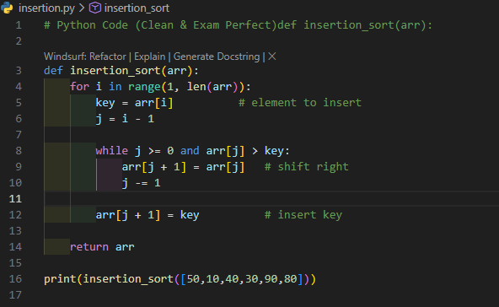
Output
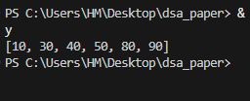

Time Complexity
Best O(n) (already sorted)
Average O(n²)
Worst O(n²)
Space O(1) in-place

How University Asks in Exam

Q1: Define Insertion Sort and write algorithm.
Write definition + flow explanation + algorithm.

Q2: Sort the following array using insertion sort:
Example:
[12, 5, 8, 3, 7]
→ Show passes with shifting.
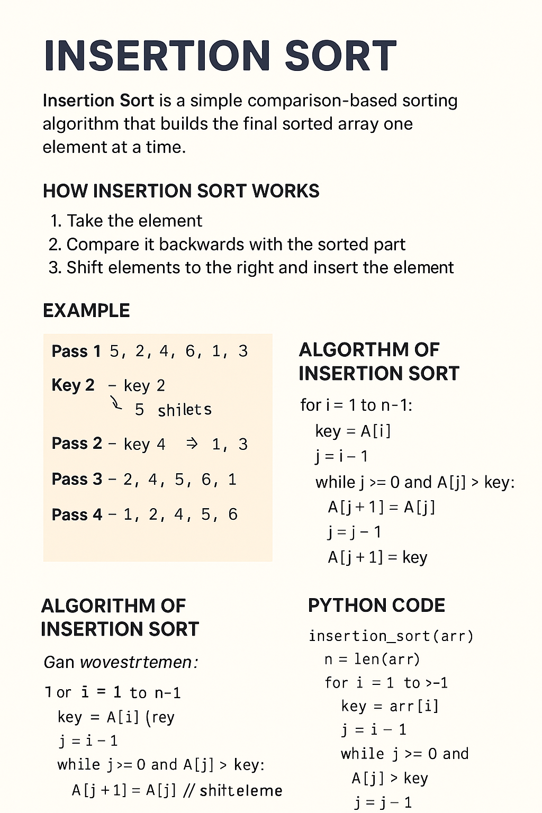
The mid course is upto insertion sort bubble sort and so on is final course

Author: Hamdan Ghazi…

